**LATIHAN PRAKTEK PBO PERT 9**

1. Latihan 1

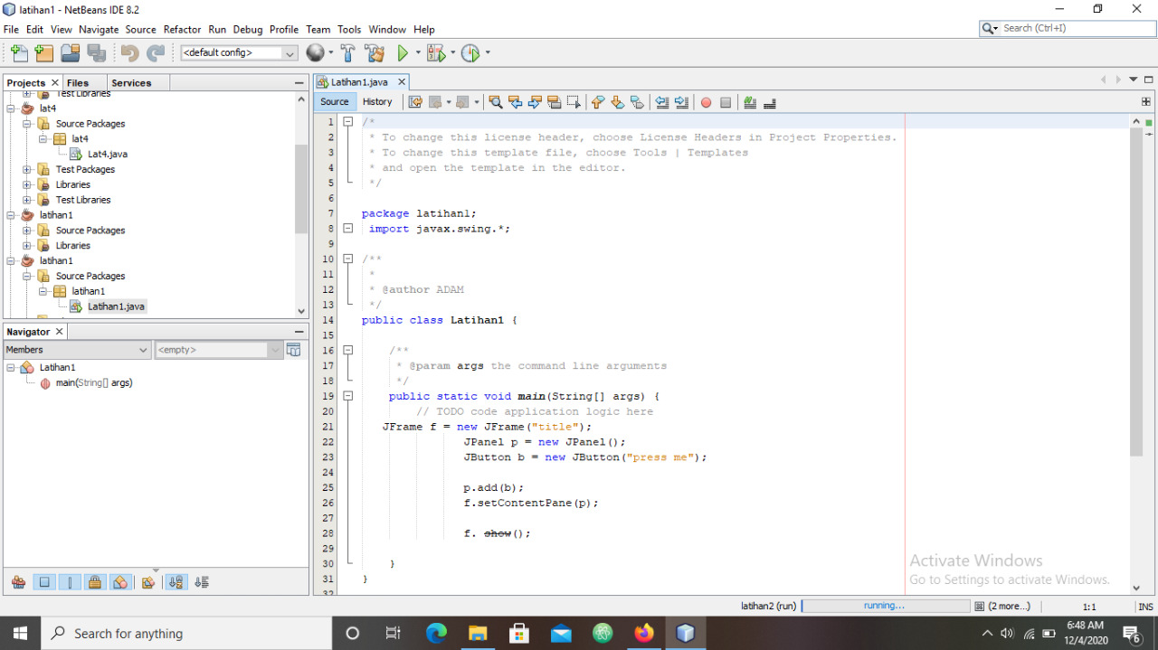

**Hasil Run Latihan 1**

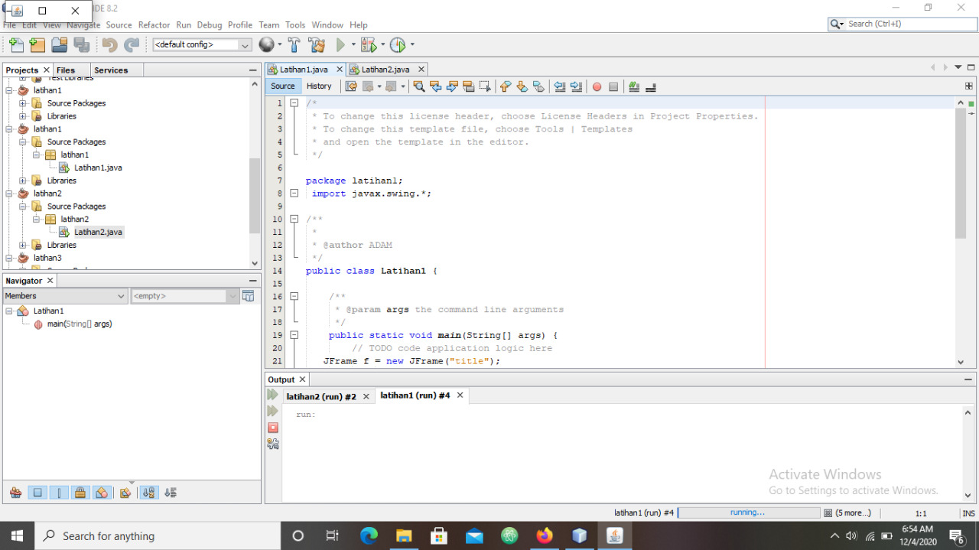

1. Latihan 2

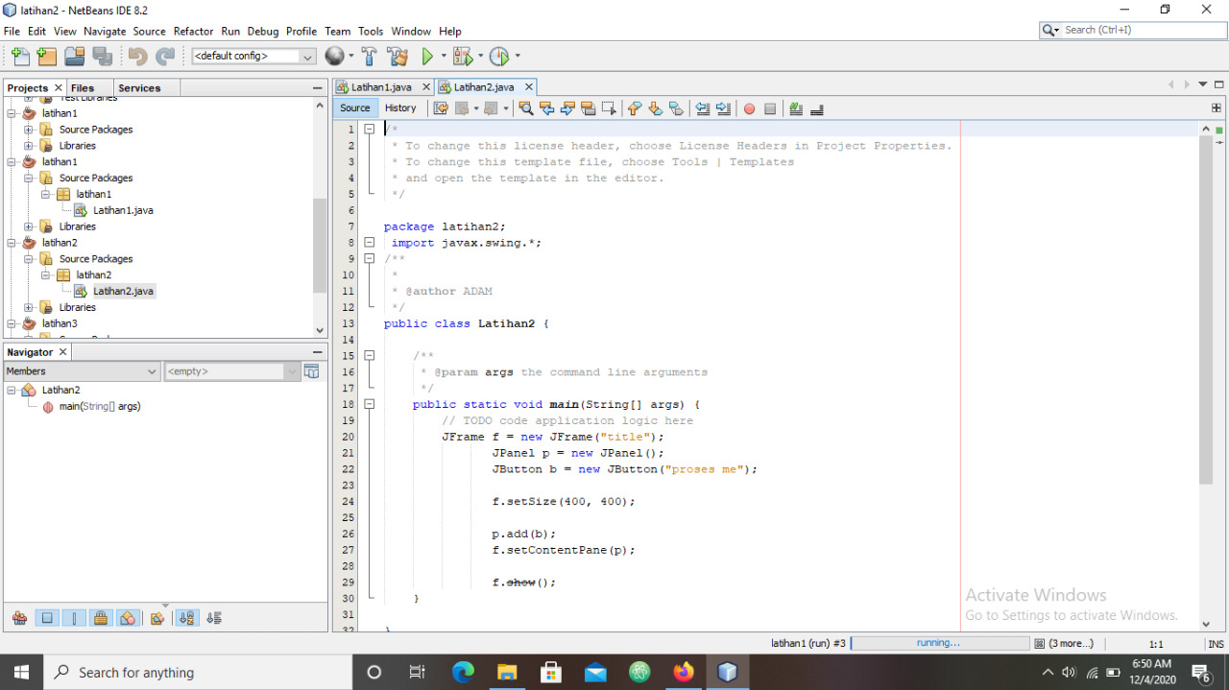

**Hasil Run latihan 2**

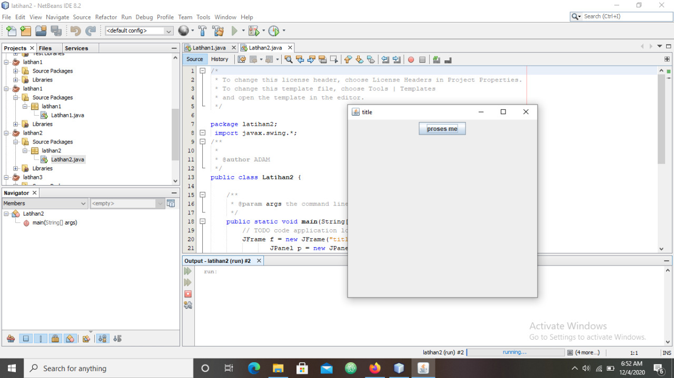

1. Latihan 3

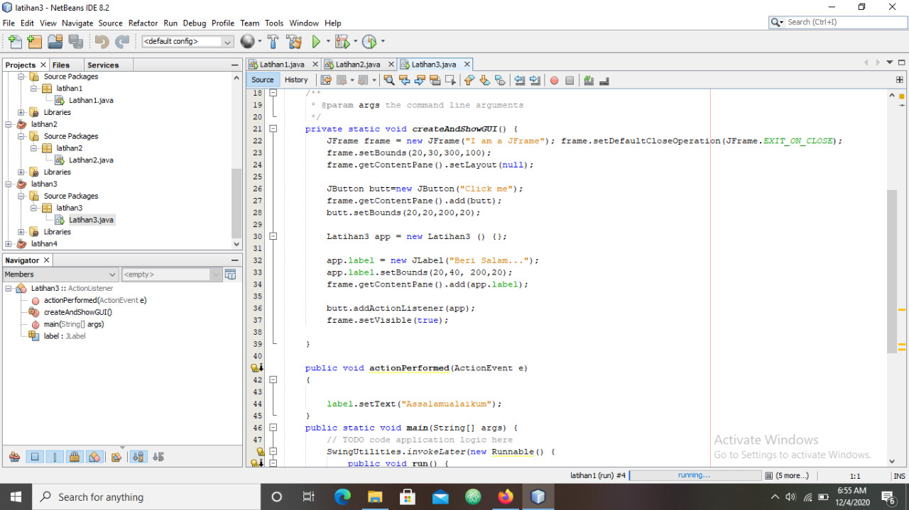

**Hasil Run (1) Latihan 3 Hasil Run (2) Latihan 3**

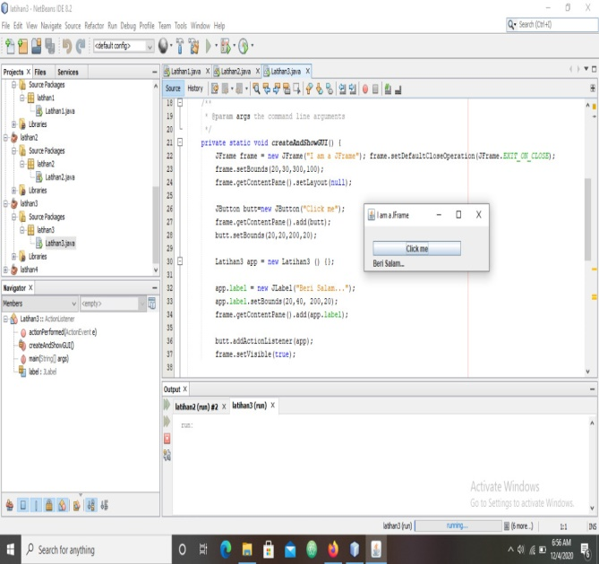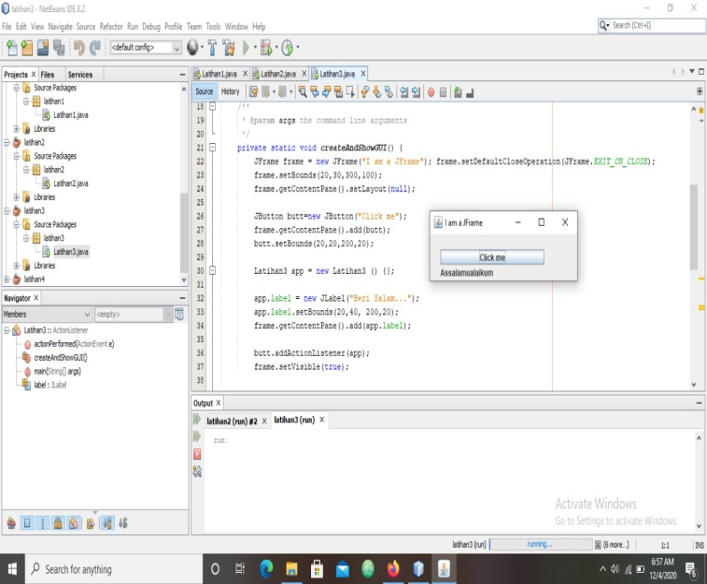

1. Latihan 4

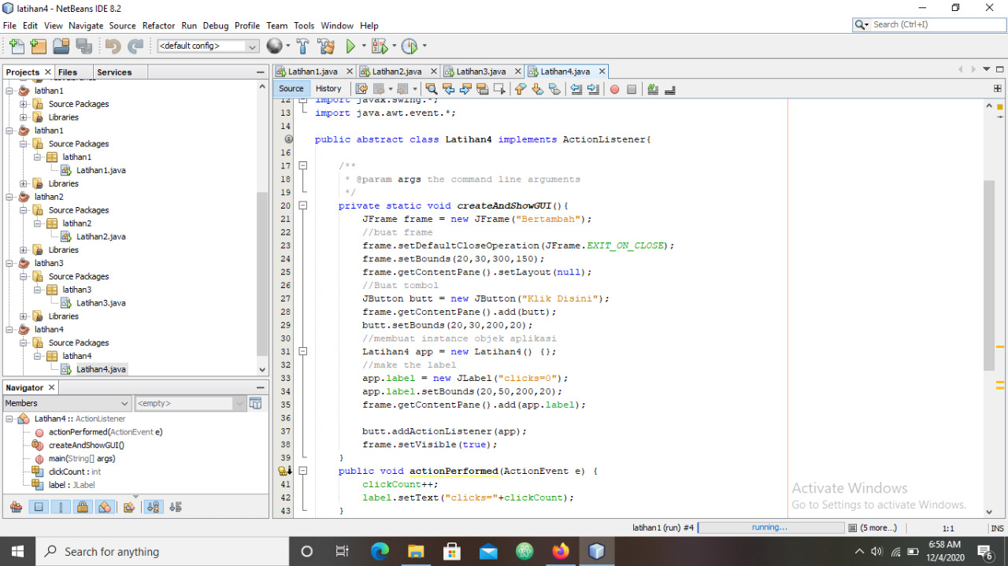

**Hasil Run Latihan 4**

